POWER BI REPORT
Walmart Sales Analysis Dashboard

Name | S. Thamilarasi
Roll No. | E25FA048
Department | B.Com FinTech with AI

Prepared from the uploaded Week 2 Power BI (.pbix) report

1. Introduction
This report presents the structure and analytical features of the Week 2 Power BI dashboard. The dashboard is designed for Walmart sales analysis and uses interactive visualizations to study sales performance by store, sales trends over time, holiday effects, fuel-price relationships, and store ranking.

2. Objectives
- To summarize important sales measures using KPI cards.
- To compare total and average weekly sales across stores.
- To observe weekly sales movement over time.
- To compare holiday and non-holiday sales.
- To examine the relationship between fuel price and weekly sales.
- To analyse changes in store ranking over time.
- To provide interactive filtering using date, store, and holiday-status slicers.

3. KPI Cards
KPI | Purpose | Use in Analysis
Total Sales | Measures overall sales performance. | Provides a high-level sales summary.
Average Sales | Shows the average sales value. | Helps understand typical sales performance.
Transaction Count | Counts sales transactions. | Indicates transaction activity.
Store Count | Counts stores represented in the analysis. | Shows the coverage of the dashboard.

4. Visualizations Used
Visualization | Chart Type | Purpose
Store Wise Total Weekly Sales | Clustered column chart | Compares total weekly sales between stores.
Weekly Sales Trend | Line chart | Shows the movement of average sales across dates.
Average Weekly Sales by Store | Clustered bar chart | Compares average sales performance across stores.
Cumulative Weekly Sale Trend | Area chart | Shows cumulative sales progression over time.
Holiday vs Non Holiday Sales | Donut chart | Shows sales split by holiday status.
Fuel Price vs Weekly Sales | Scatter chart | Examines the relationship between fuel price and weekly sales.
Store Ranking Over Time | Ribbon chart | Shows how store positions change across time periods.

5. Visualization Overview
The chart below summarizes the visual elements identified in the PBIX report. It describes the report design, not the underlying Walmart sales values.
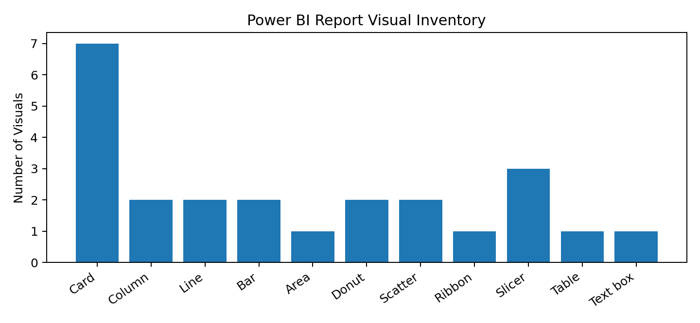

6. Financial Dashboard
The main dashboard combines KPI cards, comparative charts, trend analysis, and interactive slicers on a single page. This arrangement allows the user to move from a high-level summary to detailed store and time-based analysis.
- KPI cards provide quick access to key measures.
- Store-wise charts support comparison between stores.
- The weekly trend visual supports time-based analysis.
- The holiday visual separates holiday and non-holiday sales.
- The scatter chart is designed to examine fuel-price and sales relationships.
- Slicers allow filtering by date, store, and holiday status.

7. Key Analytical Observations
- The report is structured around sales performance rather than only raw transaction-level data.
- Store-level comparison is supported through both total-sales and average-sales visuals.
- Time-based visuals allow users to examine changes in sales across weeks and periods.
- Holiday status is treated as a separate analytical dimension.
- Fuel price is included as an external factor for relationship analysis with weekly sales.
- The ribbon chart provides a way to study changes in relative store position over time.
- Interactive slicers make the dashboard useful for focused analysis of selected dates, stores, or holiday categories.

8. Conclusion
The Week 2 Power BI dashboard provides a structured approach to Walmart sales analysis. It combines summary KPIs, comparison charts, trend visuals, relationship analysis, ranking analysis, and interactive filters. The dashboard therefore demonstrates how Power BI can convert sales data into an interactive analytical report for business decision support.

9. Tools and Technologies
- Microsoft Power BI
- DAX measures used for dashboard KPIs
- Interactive slicers and report visuals
- Walmart sales dataset represented in the PBIX file

